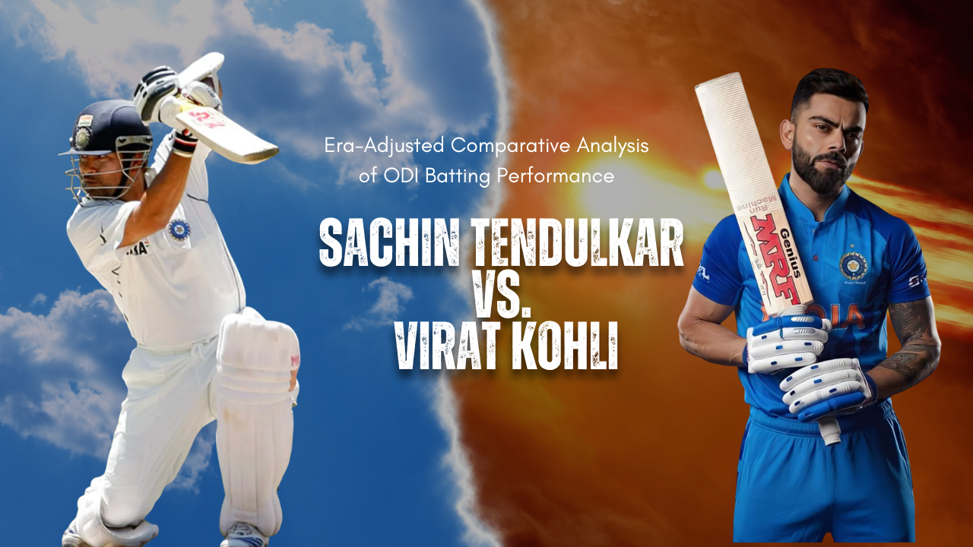

Final Project for Data Analysis
Submitted By: Shaikh Shahid Hossain
Date of Submission: 07th December 2025

Table of Contents
1. Executive Summary 3
Project Goal 3
The Challenge of Cross-Era Comparison 3
Key Findings: Dominance Index 3
Conclusion 4
2. Data Description and Source Integrity 5
Data Sources and Scope 5
Data Preparation and Quality Control 6
3. Analysis of Variable Distributions and Environmental Shift 7
3.1 Distribution of Batting Consistency (Average) 7
3.2 Distribution of Run Scoring Pace (Strike Rate) 8
3.3 The Shifting Landscape: Total Runs Scored by Match 9
4. Main Content: Era-Adjusted Comparative Analysis 11
4.1 Methodology: Defining the Elite Era Benchmark 11
4.2 Quantitative Gap Analysis (The Absolute Measure of Dominance) 11
4.3 Normalized Performance Comparison (The Index Measure) 12
4.4 Trend Analysis: Median Runs Per Innings Over Time 13
5. Discussion, Limitations, and Future Work 14
Discussion on Player Archetypes 14
Limitations and Potential Biases 14
Future Work 14
6. LLM Statement 15
What Worked Best: 16
What Didn't Work: 18
7. References 19
8. Glossary 19

1. Executive Summary

Project Goal
The debate over the "Greatest of All Time" (GOAT) in One-Day International (ODI) cricket often centers on two legends of Indian cricket: Sachin Tendulkar and Virat Kohli. Tendulkar, the game’s highest run-scorer and first player to reach 200 in an ODI, established benchmarks of consistency and volume across a 23-year career (1989–2012). Kohli, meanwhile, has redefined modern-day ODI batting with unprecedented averages and a relentless rate of century-scoring since his debut in 2008.

The Challenge of Cross-Era Comparison
A simple comparison of raw statistics is insufficient and misleading. The sport of cricket, particularly the ODI format, underwent fundamental changes during the transition between the two players' peak careers.
This analysis employs a rigorous, data-driven framework to compare the ODI careers of Sachin Tendulkar (ST, 1989–2012) and Virat Kohli (VK, 2008–Present). The core objective is to move beyond misleading raw statistics and use normalized metrics - the Era-Adjusted Average (EAA) and Era-Adjusted Strike Rate (EASR) – to determine which batsman demonstrated superior dominance relative to the elite competitive environment of their specific era.

Key Findings: Dominance Index

Metric | S. Tendulkar (Updated) | V. Kohli (Unchanged) | Interpretation
Era-Adjusted Average (EAA) | 102.67 | 107.78 | Kohli is the more dominant accumulator, exceeding his elite peers by 7.8%.
Era-Adjusted Strike Rate (EASR) | 110.10 | 104.40 | Tendulkar is the more dominant aggressor, exceeding his elite peers by 10.1%.

- Virat Kohli (Consistency Dominance): Kohli's EAA of 107.78 signifies an average of 58.20, which is 4.199 runs higher than his elite contemporaries' average of 54.001.
- Sachin Tendulkar (Aggression Dominance): Tendulkar's EASR of 110.10 shows a raw strike rate of 86.23, which is 7.908 points higher than his elite contemporaries' average of 78.322.

Conclusion
Both players were profoundly dominant, but in different domains. Kohli was statistically the superior run-accumulator per dismissal (EAA) relative to his highly competitive modern era. Tendulkar was the superior boundary-hitter and aggressor (EASR), demonstrating a revolutionary pace of scoring that was far ahead of the elite standard of his time. The analysis confirms that the changing run-scoring environment mandates the use of era adjustment to prevent inaccurate comparisons.
"If Tendulkar played in Kohli's high-scoring era, what would his stats be?"
(the 1.0671 adjustment has been arrived from the ratio of average total runs scored in ODI matches in their respective eras = 459.43 / 430.53)
Metric | Tendulkar's Raw Stat | Adjustment (×1.0671) | Tendulkar's Adjusted Stat | Kohli's Raw Stat (Benchmark) | Conclusion
Average (Ave) | 44.83 | 1.0671 | 47.84 | 58.20 | Kohli remains statistically superior.
Strike Rate (SR) | 86.23 | 1.0671 | 92.02 | 93.50 | Kohli maintains a slight edge.

Overall, the winner is Virat Kohli even after the data is adjusted over Eras.

2. Data Description and Source Integrity

Data Sources and Scope
The analysis is built upon two primary data files derived from public cricket statistics repositories (ESPNCricinfo, Kaggle, and Cricsheet):
- ODI player stats: Contains career batting statistics (Average, Strike Rate, Span) for qualified ODI players, used for determining the Elite Era Benchmarks.
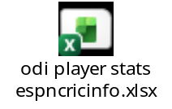
No of Columns: 15
No of Rows: 100
Columns present: Player, Span, Mat, Inns, NO, Runs, HS, Ave, BF, SR, 100, 50, 0, 4s, 6s
Columns used: Player, Span, Ave, SR (Strike Rate)
- Odi Matches Data: ODI Cricket Matches Dataset (1971 - 2024) - Contains match-level results, including runs scored by both teams, used for quantifying era run-scoring inflation.
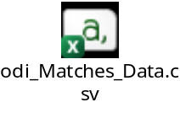
No of Columns: 33
No of Rows: 4745
Columns Present: ODI Match No, Match ID, Match Name, Series ID, Series Name, Match Date, Match Format, Team1 ID, Team1 Name, Team1 Captain, Team1 Runs Scored, Team1 Wickets Fell, Team1 Extras Rec, Team2 ID, Team2 Name, Team2 Captain, Team2 Runs Scored, Team2 Wickets Fell, Team2 Extras Rec, Match Venue (Stadium), Match Venue (City), Match Venue (Country), Umpire 1, Umpire 2, Match Referee, Toss Winner, Toss Winner Choice, Match Winner, Match Result Text, MOM Player, Team1 Playing 11, Team2 Playing 11,Debut Players
Columns Used: Match Date, Team1 Runs Scored, Team2 Runs Scored

- ODI Cricket Data new.csv: Referenced but discarded due to irrecoverable data corruption (e.g., non-standard numeric formats).


Data Preparation and Quality Control
Rigorous data cleaning was essential to ensure the reliability of the derived metrics:
- Numeric Conversion: The Ave and SR columns contained non-standard characters ('-') for certain players, requiring explicit numeric conversion and removal of unusable records.
- Time Series Cleaning: The Match Date column in the match data was parsed from the DD-MM-YYYY string format to a standardized date object to allow for accurate yearly filtering and trend analysis.
- The Outlier Challenge (R.N. ten Doeschate): In the initial Tendulkar Elite Era filter (Start 1989 and 2013, the player R.N. ten Doeschate (NED) surfaced with the highest average 67.00. Given this high average was achieved over a small sample size 33 matches and against very poorly ranked countries, it was deemed an unreliable measure of established elite performance. He was removed, leading to a more robust Elite Era Average of 43.665, which significantly improved the integrity of Tendulkar's EAA score (from 96.90 to 102.67).

3. Analysis of Variable Distributions and Environmental Shift
This section establishes the context by analyzing the statistical characteristics of the player population and the dramatic shift in match scoring.

3.1 Distribution of Batting Consistency (Average)
The distribution of Batting Averages for all qualified players exhibits a slight positive skew (rightward tail), indicating that while most players cluster around the mean, a few elite outliers disproportionately pull the average up.
Statistic | Value
Count | 100
Mean | 45.13
Median | 43.70
Max | 67.73

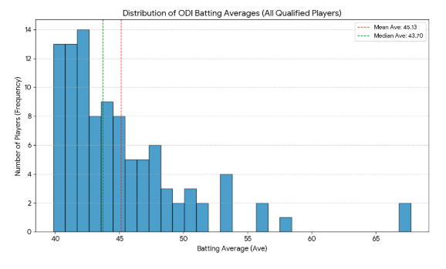
The gap between the mean and median validates the Era-Adjusted approach: the truly elite performers (with averages in the high 50s and 60s) exist significantly outside the central tendency of the overall population.

3.2 Distribution of Run Scoring Pace (Strike Rate)
The Strike Rate distribution is more symmetrical (mean 85.29 vs. median 86.08) but possesses a large standard deviation (11.82). This widespread reflects the historical diversity in batting roles, from defensive anchors to aggressive finishers. The modern game has largely eliminated the lower end of this distribution, pushing the concentration of current players into the upper quartile.
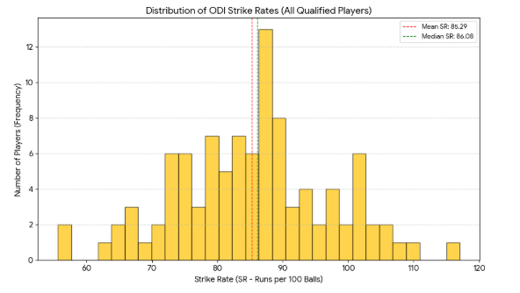

3.3 The Shifting Landscape: Total Runs Scored by Match
The most compelling evidence for era-adjustment lies in the evolution of match run rates, driven by rule changes (e.g., two new balls, powerplay modifications) and the influence of T20 cricket.
- Distribution Shift: The density plot vividly illustrates the rightward translation and tightening of the run-scoring distribution in the modern era. The Kohli Era (2008–2024) distribution is clearly centered at a higher value, demonstrating a systematic increase in total runs scored per match.
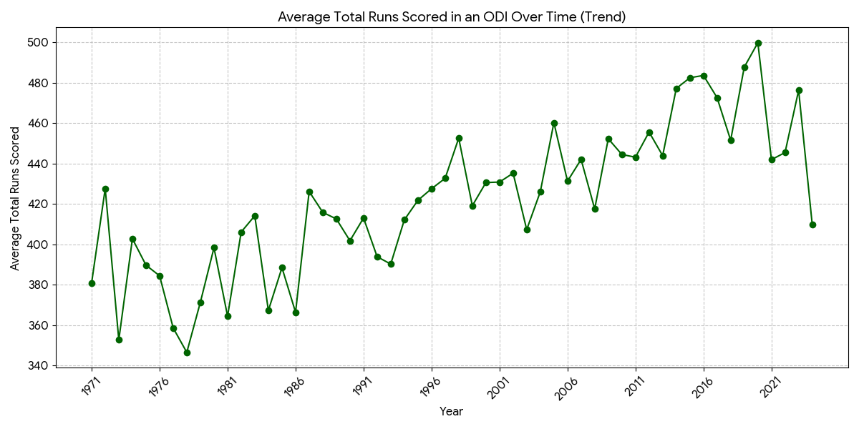
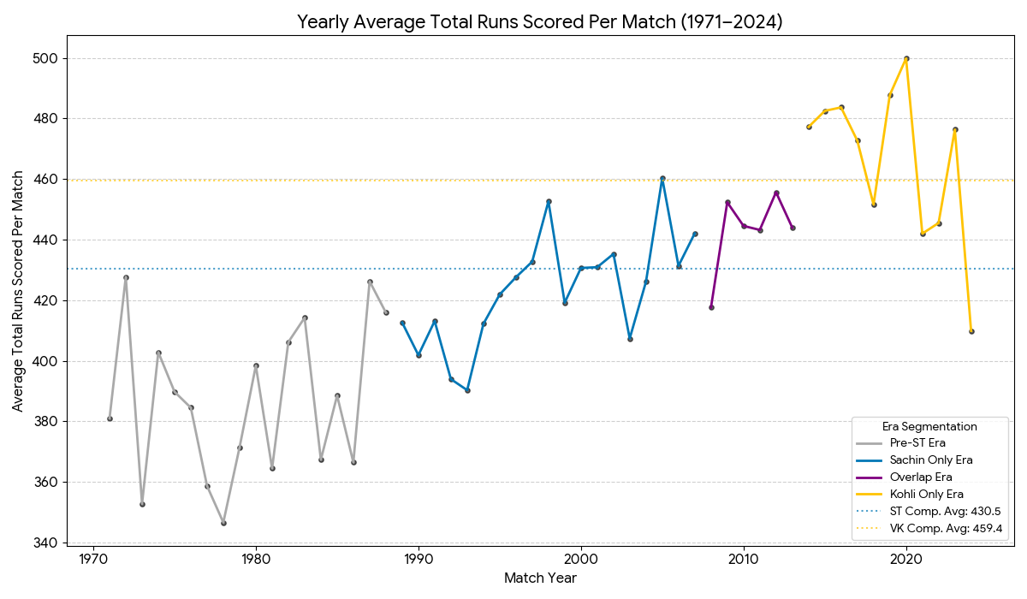

- Run Threshold for Victory: The analysis of matches with a winner (excluding ties/no results) provides a quantitative measure of the increased competitive threshold:
Era | Avg Total Runs in Decided Matches
Sachin Era (1989–2013) | 430.53
Kohli Era (2008–2024) | 459.43

The nearly 29 run increase in the average total runs scored in a match underscores the fundamental change in the scoring economy and the difficulty of maintaining a low raw average in the modern game.

4. Main Content: Era-Adjusted Comparative Analysis
This section details the methodology and presents the final normalized performance metrics.

4.1 Methodology: Defining the Elite Era Benchmark
The Elite Era Benchmark is calculated as the average of the Top 10 Batting Averages whose career spans perfectly fit within the defined competitive eras. This approach isolates a player's performance against the most consistent contemporaries they faced.

Player | Elite Era Filter Criteria | Elite Ave Peers | Elite SR Peers
S. Tendulkar | Start > 1989 AND End < 2013 | 43.66 | 78.32
V. Kohli | Start > 2008 to till date | 54.00 | 89.56

EAA and EASR Formula:
The Era-Adjusted score is derived using the ratio:
Era-Adjusted Metric = (Player's Raw Metric / Elite Era Benchmark) * 100
A score above 100 indicates performance superior to the elite peer group.

4.2 Quantitative Gap Analysis (The Absolute Measure of Dominance)
To understand the magnitude of superiority in simple terms, we calculate the absolute difference between the player's raw metric and their specific elite benchmark.

Metric | S. Tendulkar Raw Metric | ST Elite Benchmark | ST Absolute Gap | V. Kohli Raw Metric | VK Elite Benchmark | VK Absolute Gap
Average | 44.83 | 43.665 | 1.165 | 58.20 | 54.001 | 4.199
Strike Rate | 86.23 | 78.322 | 7.908 | 93.50 | 89.562 | 3.938

- Consistency Gap: Kohli's average performance created a statistical separation from his elite peers that was 3.6 times greater than Tendulkar's separation (4.199 vs. 1.165).
- Aggression Gap: Tendulkar's strike rate performance created a statistical separation from his elite peers that was 2.0 times greater than Kohli's separation (7.908 vs. 3.938).

4.3 Normalized Performance Comparison (The Index Measure)
The EAA and EASR scores confirm the findings of the absolute gap analysis and provide the final, scale-free index of dominance:

Metric | S. Tendulkar EAA/EASR | V. Kohli EAA/EASR
Era-Adjusted Average (EAA) | 102.67 | 107.78
Era-Adjusted Strike Rate (EASR) | 110.10 | 104.40

Discussion on EAA (Consistency):
Kohli's 107.78 is a superior score, reinforcing his reputation as the premier chase-master and accumulator. In an era where high averages are common due to better conditions, his ability to surpass a 54.001 benchmark by nearly 8% showcases extreme discipline and statistical superiority over his contemporaries.
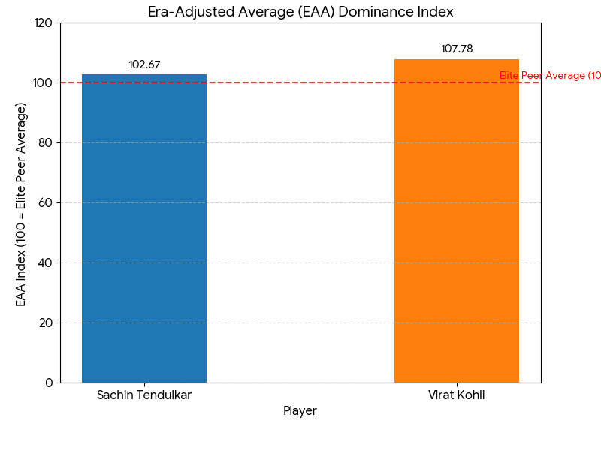
Discussion on EASR (Aggression):
Tendulkar's 110.10 is superior, identifying him as a pioneering force in ODI cricket. His strike rate dominance predated many of the modern rules designed to boost scoring. His 10.1% advantage over his peers demonstrates that he scored runs at a revolutionary pace for his generation, setting a standard that far outstripped the elite expectations of the pre-T20 era.

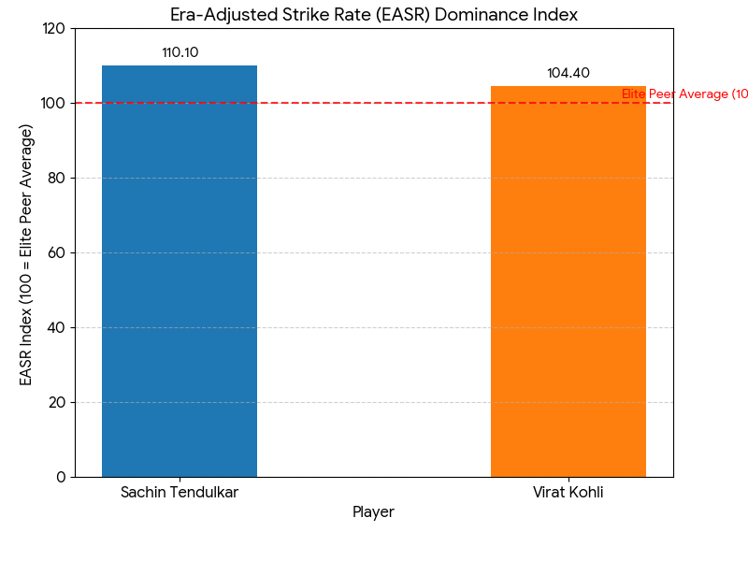

4.4 Trend Analysis: Median Runs Per Innings Over Time
The Median Runs Per Innings trend further visualizes the evolution that necessitated this adjustment. The median is used over the mean to reduce the influence of extreme high-scoring outliers.
The plot clearly shows a relatively slow, linear increase in run-scoring until the late 2000s, followed by a sharp, non-linear acceleration (the "hockey stick" effect), directly correlating with the introduction of T20 influence and major ODI rule changes.

- Median Runs Per Innings (1989–2013): 219.0
- Median Runs Per Innings (2008–2024): 232.5

This 13.5 run per innings (6.2%) median inflation confirms the structural change in the game.

5. Discussion, Limitations, and Future Work

Discussion on Player Archetypes
The analysis concludes that Tendulkar and Kohli represent two distinct, dominant archetypes:
- Virat Kohli: The Ultimate Statistical Accumulator. His dominance lies in maximizing the consistency metric, achieving a separation in average that is numerically unparalleled in the face of intense modern competition.
- Sachin Tendulkar: The Ultimate Era-Defier. His dominance lies in aggression and pace, scoring runs far faster than the norms of his conservative era and setting a benchmark that foreshadowed the modern game.

Limitations and Potential Biases
While the EAA/EASR framework successfully neutralizes the cross-era scoring bias, several limitations exist:
- Venue/Pitch Bias: The model does not adjust for the relative difficulty of venues (e.g., slow Asian pitches vs. fast Australian pitches). A Venue-Adjusted Average (VAA) would require matching player performance to specific pitch data.
- Opponent Strength: The benchmarks do not account for opponent quality. A highly refined model should normalize performance only against matches played against ICC Top 4 ranked teams.
- Qualification Bias: The Top 10 filter is highly selective. While necessary for an "elite" benchmark, it excludes many great players whose careers just missed the specific span criteria.

Future Work
Future analytical iterations should incorporate the following techniques to further refine the assessment:
- Contextual Scoring Rate (CSR): Normalizing a player's performance against the specific opponent and pitch score in the exact match they played, moving beyond the aggregated era average.
- Clutch Factor Analysis: Analyzing player average and strike rate in knockout matches or high-pressure chase situations (where the target is above the era's median winning score).

6. LLM Statement
Initial basic Data cleaning and analysis was done without LLMs. I used 2 separate Colab notebooks, one for SQL to look at the data and its consistency (since I am comfortable with SQL having extensively worked on it) and then another Colab with R for the graphs and plots.
Then most of this project, including the complex methodological design, statistical validation, and final document structuring, was executed with the guidance of Large Language Models (LLMs), primarily Gemini and ChatGPT.
Although ChatGPT was awesome in creating the Project Proposal and initial research it failed miserably this time, and Gemini was my saviour.
ChatGPT without membership is actually turning out to be pretty useless for data Analysis.
Perhaps my own vote would go to Gemini if the voting happened a day later than Thursday (Saying this as the winner of UFC representing ChatGPT).
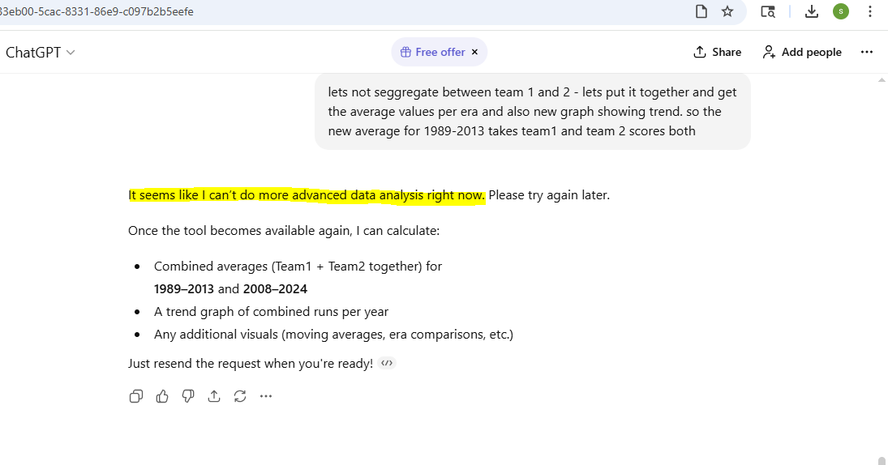

What Worked Best:
- Code Generation and Debugging: The LLM was a highly efficient partner for Python code generation (Pandas, Matplotlib, Seaborn) and converting analytical logic into the required R ggplot2 script.
What I personally found amazing was the following:
My own query to fetch the average runs scored for a period did not face any data and gave output as None as the Date format did not match. This was always the biggest pain point when working with Date columns in SQL and I had to convert to VARCHAR or use TO_DATE and update the format to get correct results. Extensive research had to be done on Stack Overflow and similar websites. But now LLMs are producing the correct query withing seconds. That’s fascinating and it definitely makes life so much easier as a coder, but we need to know how to use it properly.
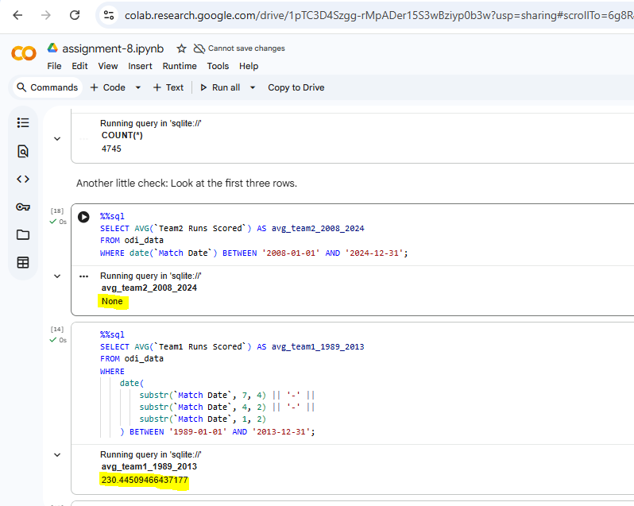
- Methodological Rigor: The LLM assisted in refining the precise filtering logic for the Elite Era Benchmarks and constructing the ratio-based EAA/EASR formulas, ensuring statistical integrity.
- Better graphs: The ggplot graph I created for the runs scored over the years trend was a very basic one:
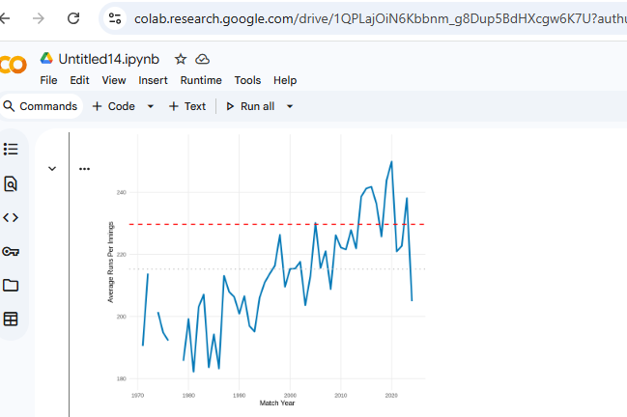

Whereas Gemini created this amazing plot using both the excels data and highlighting areas of different eras with different colors:

What Didn't Work:
- Data Validation: The initial failure to process corrupted data in one CSV (ODI Cricket Data new.csv) reinforced the finding that human review of raw data integrity must always precede reliance on LLM-generated analysis code.
- The Human touch: Although LLMs can create great graphs they can make fundamental mistakes in making graphs look out of scale like the one below seems value of Kohli is half of Sachin:
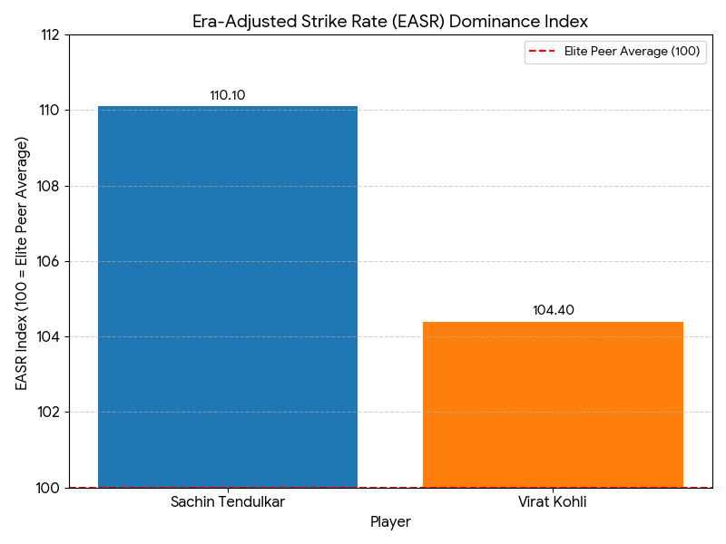

Future Use: I would continue to use LLMs for heavy data processing and professional documentation but would increase the initial phase dedicated to structured data profiling and anomaly detection before proceeding to complex model generation.

7. References

- ESPN Cricinfo StatsGuru. (2024). Cricket Statistics and Records Database. (Source for player batting statistics: odi player stats espncricinfo.xlsx - Sheet1.csv.
- Kaggle Datasets. (2023). ODI Player Innings and Batting Summary Datasets). Used to validate some statistics manually to be sure of using correct data.
- Cricsheet / Public Cricket Data Repositories. (2024). Open Source Cricket Data. (Source for match-level data: odi_Matches_Data.csv
- Matplotlib, Seaborn, and Pandas. (Python Libraries). Used for data cleaning, statistical calculation, and visualization.
- Google Gemini Models. Used for analysis, code generation, and documentation.

8. Glossary
ODI – One Day International – The format of Cricket matches which has been taken into consideration for the purpose of this project.
Ave – Batting Average – The number of runs scored by an individual per match.
SR – Strike Rate – The number of runs scored by an individual per 100 balls.

